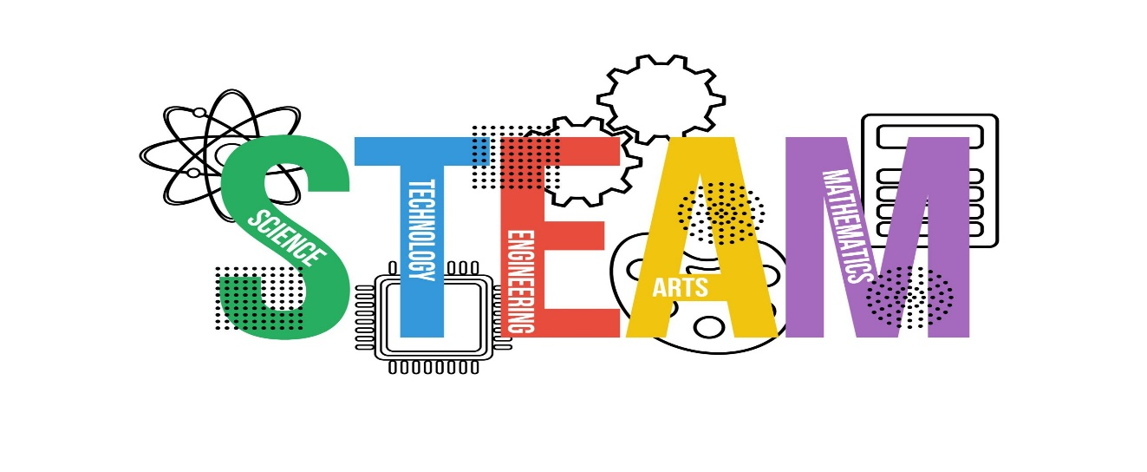**Join Bissett STEAM Club!**

We want to invite you to be a part of the Bissett STEAM Club this year. Due to COVID-19 precautions, this will be held virtually through Canvas and Zoom this school year.

**WHO:** Any 3rd through 5th grader that is interested in science, technology, engineering, arts, or mathematics.

**WHEN:** Every other Wednesday at 3:00 Pm on Zoom.

**WHAT:** We will be sending home material kits with our students that have signed up so that they can do fun, hands-on activities at home.

**HOW:** Use the QR code below to register your child or head to https://www.sps.org/bissett and click the Activities tab under Students for to access the sign-up link.

